Program:simple calc

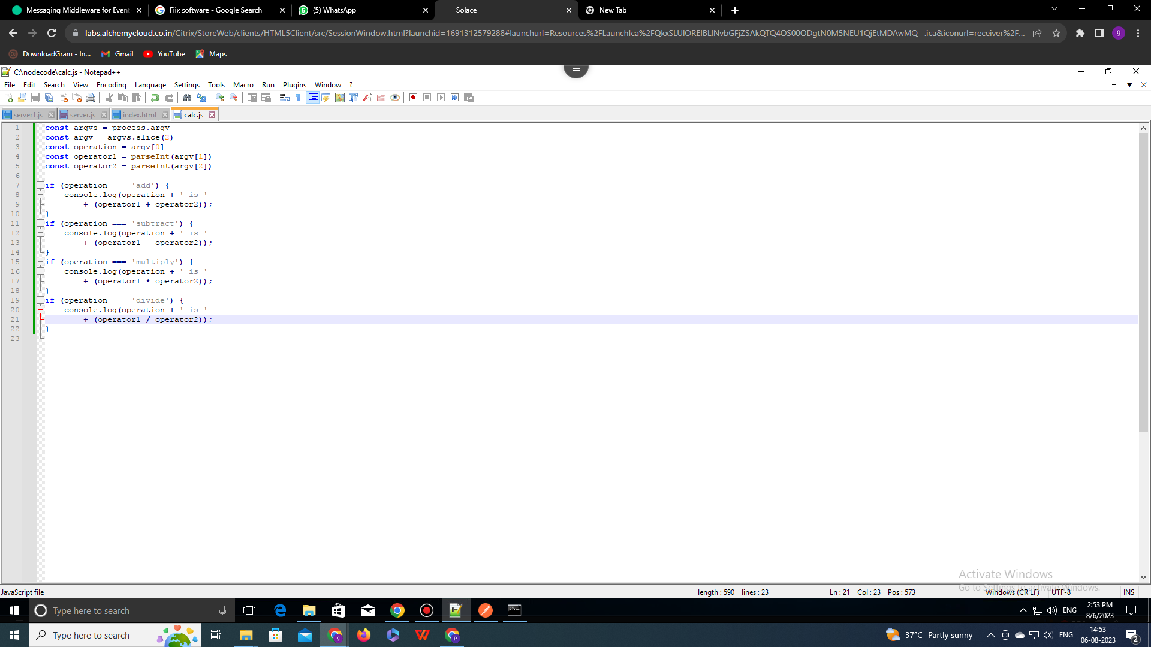

This is a program for calc

const argvs = process.argv

const argv = argvs.slice(2)

const operation = argv[0]

const operator1 = parseInt(argv[1])

const operator2 = parseInt(argv[2])

**if** (operation === 'add') {

console.log(operation + ' is '

+ (operator1 + operator2));

}

**if** (operation === 'subtract') {

console.log(operation + ' is '

+ (operator1 - operator2));

}

**if** (operation === 'multiply') {

console.log(operation + ' is '

+ (operator1 + operator2));

}

**if** (operation === 'divide') {

console.log(operation + ' is '

+ (operator1 - operator2)

terminal:

